NEWS RELEASE

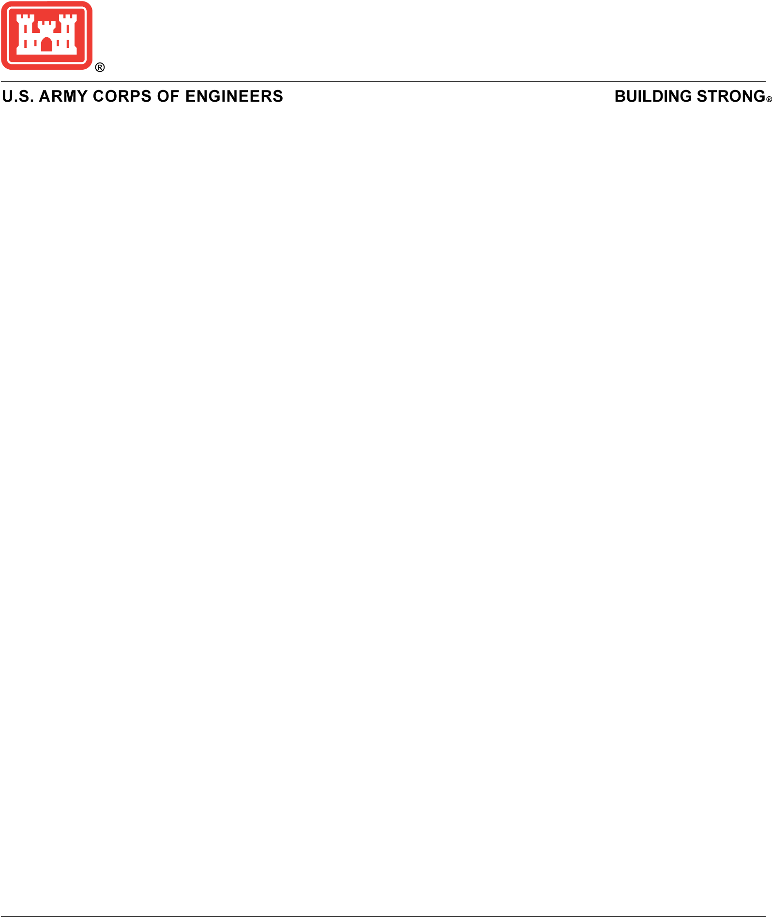­

Contact:

Doug Garman, 202-761-1807

[doug.m.garman@usace.army.mil](mailto:doug.m.garman@usace.army.mil)

Gene Pawlik202-761-7690

[Eugene.A.Pawlik@usace.army.mil](mailto:Eugene.A.Pawlik@usace.army.mil)

For Immediate Release:

September 15, 2020

**Army Corps of Engineers seeks public comments**

**on proposal to renew and revise nationwide permits**

**WASHINGTON –** The U.S. Army Corps of Engineers announced today it is seeking comments on its proposal to renew and revise 52 nationwide permits for work in wetlands and other waters that are regulated by Section 404 of the Clean Water Act and/or Section 10 of the Rivers and Harbors Act of 1899. In addition, USACE is proposing to issue five new nationwide permits that pertain to authorizing seaweed mariculture activities, finfish mariculture activities, electric utility line and telecommunications activities, utility line activities for water and other substances, and water reclamation and reuse facilities.

“We believe the set of nationwide permits being proposed today meets our goals of simplifying and clarifying the nationwide permits, as well as reducing burdens on the regulated public, while continuing to protect our nation’s wetlands and aquatic resources,” said. Maj. Gen. William H. Graham, U.S. Army Corps of Engineers, Deputy Commanding General for Civil and Emergency Operations.

The nationwide permits authorize activities that are similar in nature and cause only minimal adverse environmental impacts to aquatic resources separately or on a cumulative basis. Activities range from work associated with aids to navigation and utility lines to residential developments and maintenance activities.

Many of the nationwide permits being proposed remain unchanged from 2017, the last time the nationwide permits were authorized.

USACE division engineers may add, after public review and consultation, regional conditions to nationwide permits in order to protect local aquatic ecosystems such as fens or bottomland hardwoods or to minimize adverse effects on fish or shellfish spawning, wildlife nesting or other ecologically critical areas.

A public notice soliciting comments on the proposed set of revised nationwide permits was published in the Sept. 15, 2020, Federal Register at <https://www.federalregister.gov/documents/2020/09/15/2020-17116/proposal-to-reissue-and-modify-nationwide-permits>. USACE will accept written comments through Nov. 16, 2020. Comments may be submitted by e-mail to [nationwidepermits2020@usace.army.mil](mailto:nationwidepermits2020@usace.army.mil) or through the Federal eRulemaking portal at [www.regulations.gov](http://www.regulations.gov) at docket number COE-2020-0002. The current set of nationwide permits expire on March 18, 2022. The nationwide permits being proposed today will replace the existing set.

Additional information on the USACE regulatory program can be found at <http://www.usace.army.mil/Missions/CivilWorks/RegulatoryProgramandPermits.aspx>.

-30-